**LAB 6 TASKS**

**Q1:**

INCLUDE Irvine32.inc

.code

main PROC

mov ebp, 0

mov edx,1

mov ebx, edx

mov ecx, 10

l1:

mov eax, edx

mov ebp, eax

mov edx, ebx

add ebx, ebp

call writedec

call crlf

loop l1

exit

main ENDP

END main

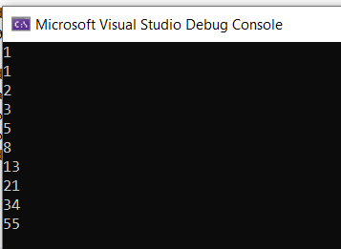

**Q2:**

INCLUDE Irvine32.inc

.data

array1 DWORD 8h, 5h, 1h, 2h, 6h

i DWORD 0

temp DWORD ?

.code

main PROC

mov ecx, 4

l1:

mov temp, ecx

mov eax, 0

mov ebx, 0

sub ecx, i

mov esi, 0

mov edi, 1

l2:

mov eax, array1[esi*TYPE array1]

mov ebx, array1[edi*TYPE array1]

cmp eax, ebx

JG exchange

JLE cont

exchange:

mov eax, array1[esi*TYPE array1]

mov ebx, array1[edi*TYPE array1]

xchg eax, array1[edi*TYPE array1]

xchg ebx, array1[esi*TYPE array1]

cont:

inc esi

inc edi

cmp ecx, 0

JLE outsideinner

loop l2

outsideinner:

mov ecx, temp

inc i

loop l1

mov edi, 0

mov ecx, LENGTHOF array1

mov esi, 0

l3:

mov eax, array1[esi*TYPE array1]

inc esi

call writedec

call crlf

loop l3

exit

main ENDP

END main

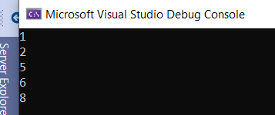

**Q3a:**

INCLUDE Irvine32.inc

.data

val1 byte '1',0

j dword ?

.code

main PROC

mov j,1

mov ecx,4

outer:

mov ebx,ecx

mov ecx,j

inner:

mov al,val1

call writechar

Loop inner

mov ecx,ebx

inc j

call Crlf

Loop outer

call DumpRegs

exit

main ENDP

END main

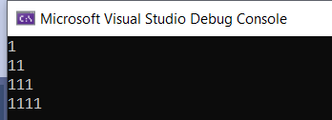

**3b:**

INCLUDE Irvine32.inc

.data

val1 byte '1 ',0

i dword ?

.code

main PROC

mov i,4

mov ecx,4

outer:

mov ebx,ecx

inner:

mov al,val1

call WriteChar

Loop inner

mov ecx,ebx

dec i

call Crlf

Loop outer

call DumpRegs

exit

main ENDP

END main

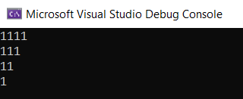

**3c:**

INCLUDE Irvine32.inc

.data

i byte ?

.code

main PROC

mov i,4

mov ecx,4

outer:

mov ebx,ecx

mov eax,4

inner:

mov eax,eax

call WriteDec

sub eax,1

Loop inner

mov ecx,ebx

dec i

call Crlf

Loop outer

call DumpRegs

exit

main ENDP

END main

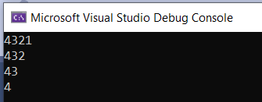

**3d:**

INCLUDE Irvine32.inc

.data

i byte ?

.code

main PROC

mov i,4

mov ecx,4

outer:

mov ebx,ecx

mov eax,1

inner:

mov eax,eax

call WriteDec

add eax,1

Loop inner

mov ecx,ebx

dec i

call Crlf

Loop outer

call DumpRegs

exit

main ENDP

END main

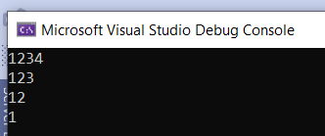

**Q4:**

INCLUDE Irvine32.inc

.data

sum dword 0h

AnnualSalary DWORD 5 DUP(?)

s1 BYTE "Enter a Employee Id: ", 0

s2 BYTE "Enter a Employee name: ", 0

s3 BYTE "Enter Year of Birth : ", 0

s4 BYTE "Enter Annual Salary : ", 0

s5 BYTE "Total Annual Salary :", 0

id DWORD 5 DUP(?)

myname BYTE 20 DUP(?)

Byear DWORD 4 DUP(?)

salary DWORD 4 DUP(?)

.code

main PROC

mov ebx,0

mov ecx, 5

mov edi ,ecx

L1:

mov edx, OFFSET s1

call WriteString

call ReadHex

mov id[ebx],eax

mov edx, OFFSET s2

call WriteString

mov edx,offset myname

mov ecx,sizeof myname

call Readstring

mov edx, OFFSET s3

call WriteString

call ReadHex

mov Byear[ebx],eax

mov edx, OFFSET s4

call WriteString

call ReadHex

mov salary[ebx],eax

add sum ,eax

inc ebx

mov ecx ,edi

dec edi

loop L1

call crlf

mov edx, OFFSET s5

call WriteString

mov eax,sum

call writedec

exit

main ENDP

END main

**Q5:**

INCLUDE Irvine32.inc

.data

source BYTE 'g','o','k','u','s','o','n',0

target BYTE LENGTHOF source DUP(?),0

.code

main PROC

mov ecx,lengthof source

L1:

mov al,source[ecx-1]

mov target[ecx-1],al

loop L1

mov edx,offset target

call WriteString

call DumpRegs

exit

main ENDP

END main

**Q6:**

INCLUDE Irvine32.inc

.data

array byte 1,2,4,8

.code

main PROC

mov ecx,(lengthof array/2)

mov esi,(lengthof array-1)

mov edx,0

L1:

mov al,array[esi]

mov bl,array[edx]

mov array[edx],al

mov array[esi],bl

dec esi

inc edx

loop L1

mov ecx,(lengthof array)

mov edx,0

mov eax,0

L2:

mov al,array[edx]

call WriteDec

inc edx

Loop L2

call DumpRegs

exit

main ENDP

END main

